Union Bank of India signs MOU with Mahindra and Mahindra Limited.

Mumbai : September 06, 2016 : Union Bank of India has entered into MOU with Mahindra and Mahindra Limited, for financing their Commercial Vehicles PAN India.

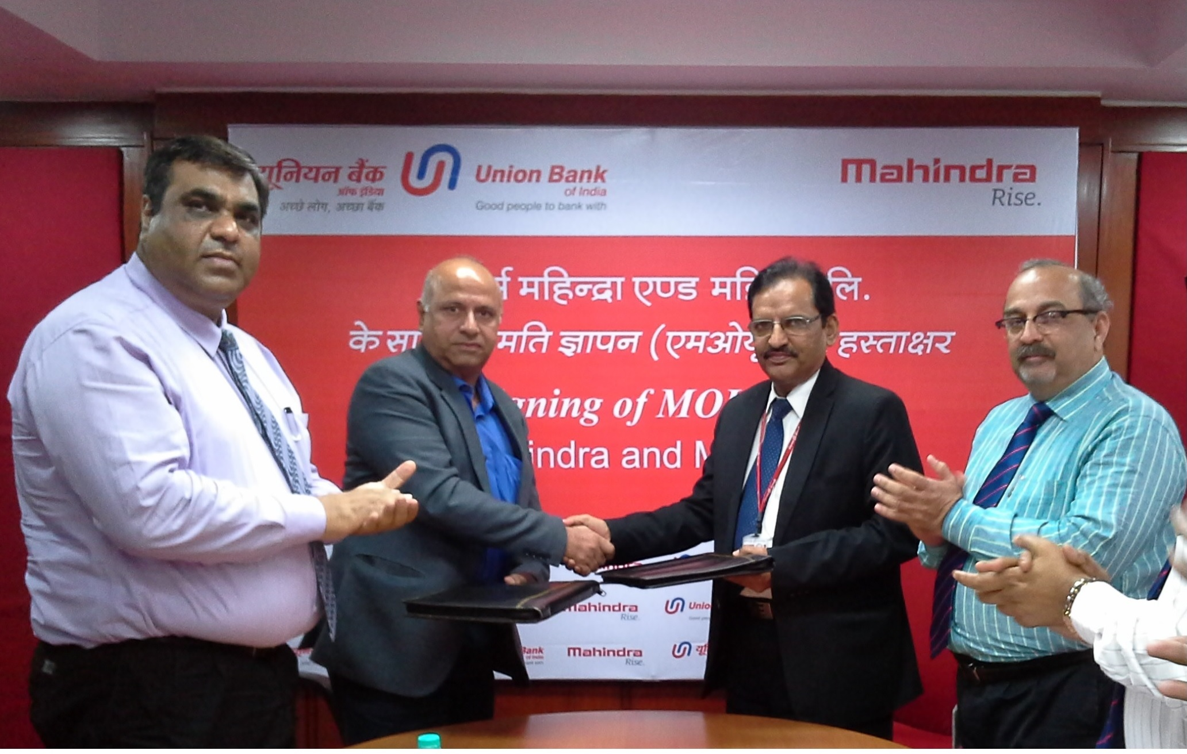

(Seen in the photograph Shri.D.C.Chauhan, General Manager, Union Bank of India exchanging MOU with Shri.Ravindranath K A, General Manager, Mahindra and Mahindra Limited in the presence of Shri.Keshav Baijal, Deputy General Manager, Union Bank of India and Mr Naveen Bathla, Deputy General Manager, Mahindra and Mahindra Limited)

______________________________________________________________________
Released on behalf of Union Bank of India by:-
Monika Kalia, GM, Corporate Communication; Tel: 22896600; E-mail: monikakalia@unionbankofindia.com

